## **Objectives**

* Explain about conditional rendering in React
* Define element variables
* Explain how to prevent components from rendering

In this hands-on lab, you will learn how to:

* Implement conditional rendering in React applications

## **Prerequisites**

The following is required to complete this hands-on lab:

* Node.js
* NPM
* Visual Studio Code

**src/components/GuestPage.js**

import React from "react";

export default function GuestPage({ onLogin }) {

return (

<div style={{ padding: 20 }}>

<h2>Welcome, Guest</h2>

<p>Here are the available flight details:</p>

<ul>

<li>Flight AI-202 — Delhi → Mumbai — 10:00 AM</li>

<li>Flight AI-305 — Mumbai → Bangalore — 3:30 PM</li>

</ul>

<p style={{ color: "red" }}>Login to book tickets.</p>

<button onClick={onLogin}>Login</button>

</div>

);

}

**src/components/UserPage.js**

import React from "react";

export default function UserPage({ onLogout }) {

return (

<div style={{ padding: 20 }}>

<h2>Welcome, User</h2>

<p>Here are the available flight details and booking options:</p>

<ul>

<li>Flight AI-202 — Delhi → Mumbai — 10:00 AM — <button>Book Ticket</button></li>

<li>Flight AI-305 — Mumbai → Bangalore — 3:30 PM — <button>Book Ticket</button></li>

</ul>

<button onClick={onLogout}>Logout</button>

</div>

);

}

**src/App.js:**

import React, { useState } from "react";

import GuestPage from "./components/GuestPage";

import UserPage from "./components/UserPage";

export default function App() {

const [isLoggedIn, setIsLoggedIn] = useState(false);

let page; // element variable for conditional rendering

if (isLoggedIn) {

page = <UserPage onLogout={() => setIsLoggedIn(false)} />;

} else {

page = <GuestPage onLogin={() => setIsLoggedIn(true)} />;

}

return (

<div>

<header style={{ backgroundColor: "#007bff", color: "white", padding: 10 }}>

<h1>Ticket Booking App</h1>

</header>

{page}

</div>

);

}

## **Notes**

Estimated time to complete this lab: **60 minutes.**

Create a React Application named “ticketbookingapp” where the guest user can browse the page where the flight details are displayed whereas the logged in user only can book tickets.

The Login and Logout buttons should accordingly display different pages. Once the user is logged in the User page should be displayed. When the user clicks on Logout, the Guest page should be displayed.

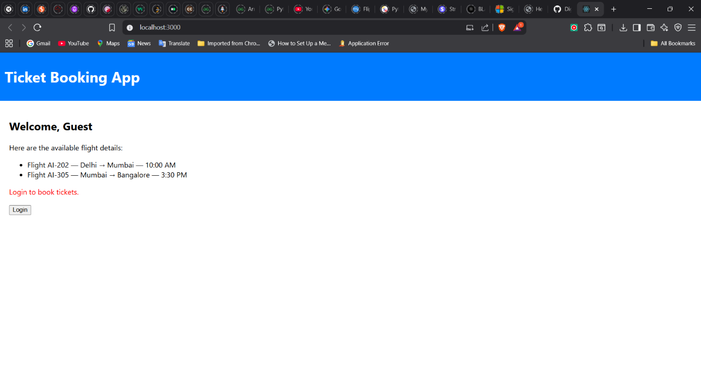

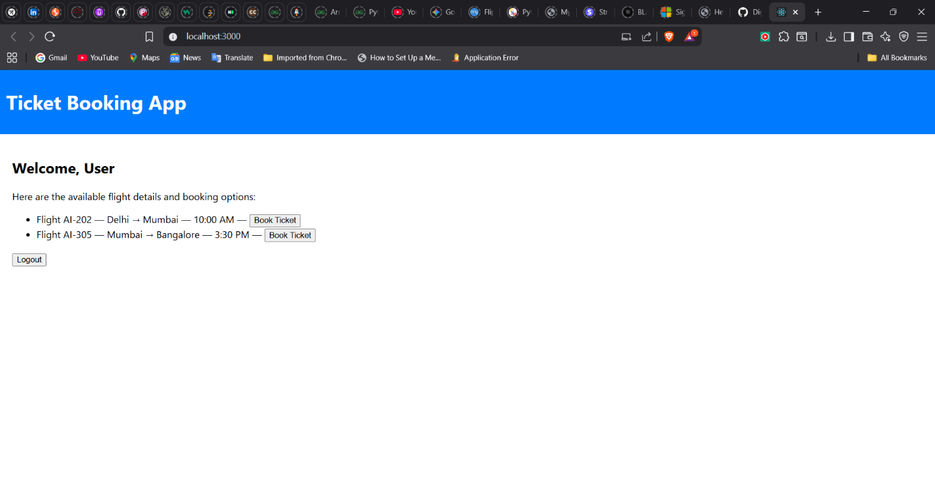

**Hint:**

